PERIPLO VARIETE
Periplo Marionetas

Premiere, September 2017, at Off Festival Mondial des Théâtres Charleville Mézière (France). String puppets variety show, whose cast are the most charismatic characters that are part of the Company, made by hands and soul of Periplo Marionetas. Music, dance, trained animals and shows with celebrities, a classic varieté. Show for all audiences (recommended +3 years).

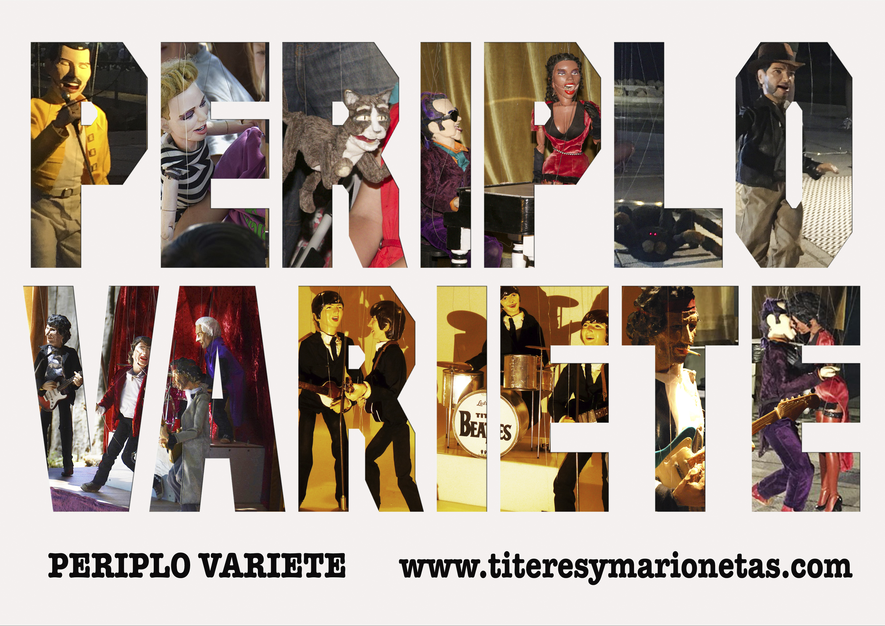

. Sinopsis: Periplo Variete is a string puppet music show, where improvisation with the audience is essential. The cast are realistic puppets who interact each other: the four of Liverpool, TitiriBeatles; the rock band, Rolling Puppets; A jazz diva, Ella; A provocative rock pianist, Jack; An apprentice of clown, Blonde and an acrobat cat, Mr. Cat. The children (as well as the older ones) are sure to have a great time. And so many surprise...

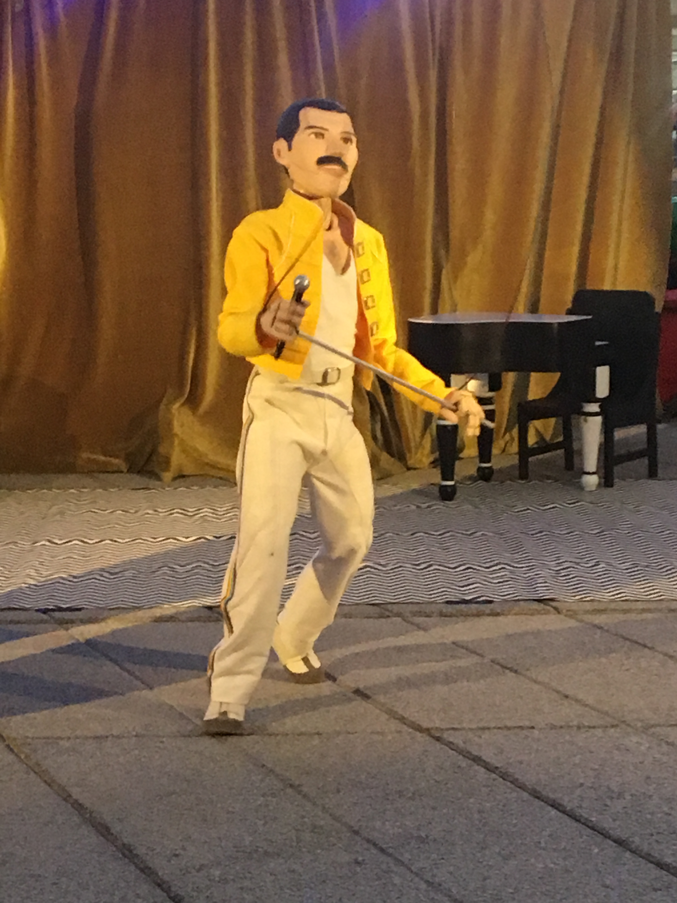

. Duration: 35/40 minutes. After the performance we show, in small groups, the puppets closely and the audeince can take pictures. Total duration: 45/60 min. (according to the characteristics of the event).
The show has been at: Getafe Street Festival (FITEC 2017, Madrid), Bienal of Theatre of Ceará (Brasil, 2017), Festival Titirifuente 2018 (Fuenlabrada, Madrid), Festival Petits Camaleons 2018 (Sant Cugat, Barcelone), Girando por Plazas 2019 (Alpedrete, Madrid), RFM SOMNII Music Festival of Figueira 2019 (Portugal), OFF Festival d’Aurillac 2019 (Francia), Certamen de Artistas de Calle de Aranda de Duero 2019 (Burgos, Spain).

. More info and photos:
https://periplosomos.wixsite.com/periplopuppets/periplo-variete

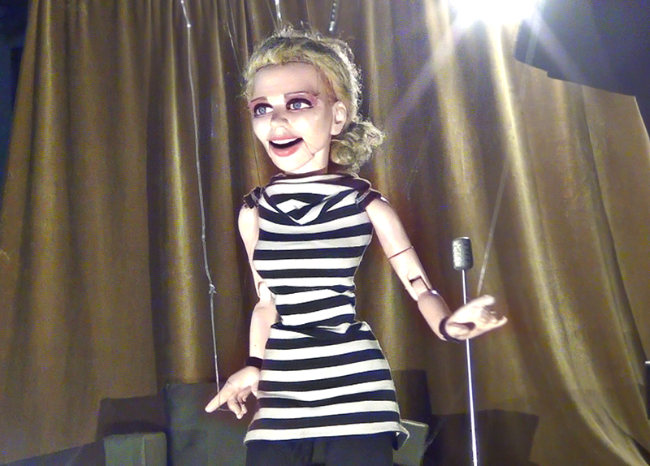

. Teasers: https://youtu.be/IuACPjzg648
https://vimeo.com/236606242

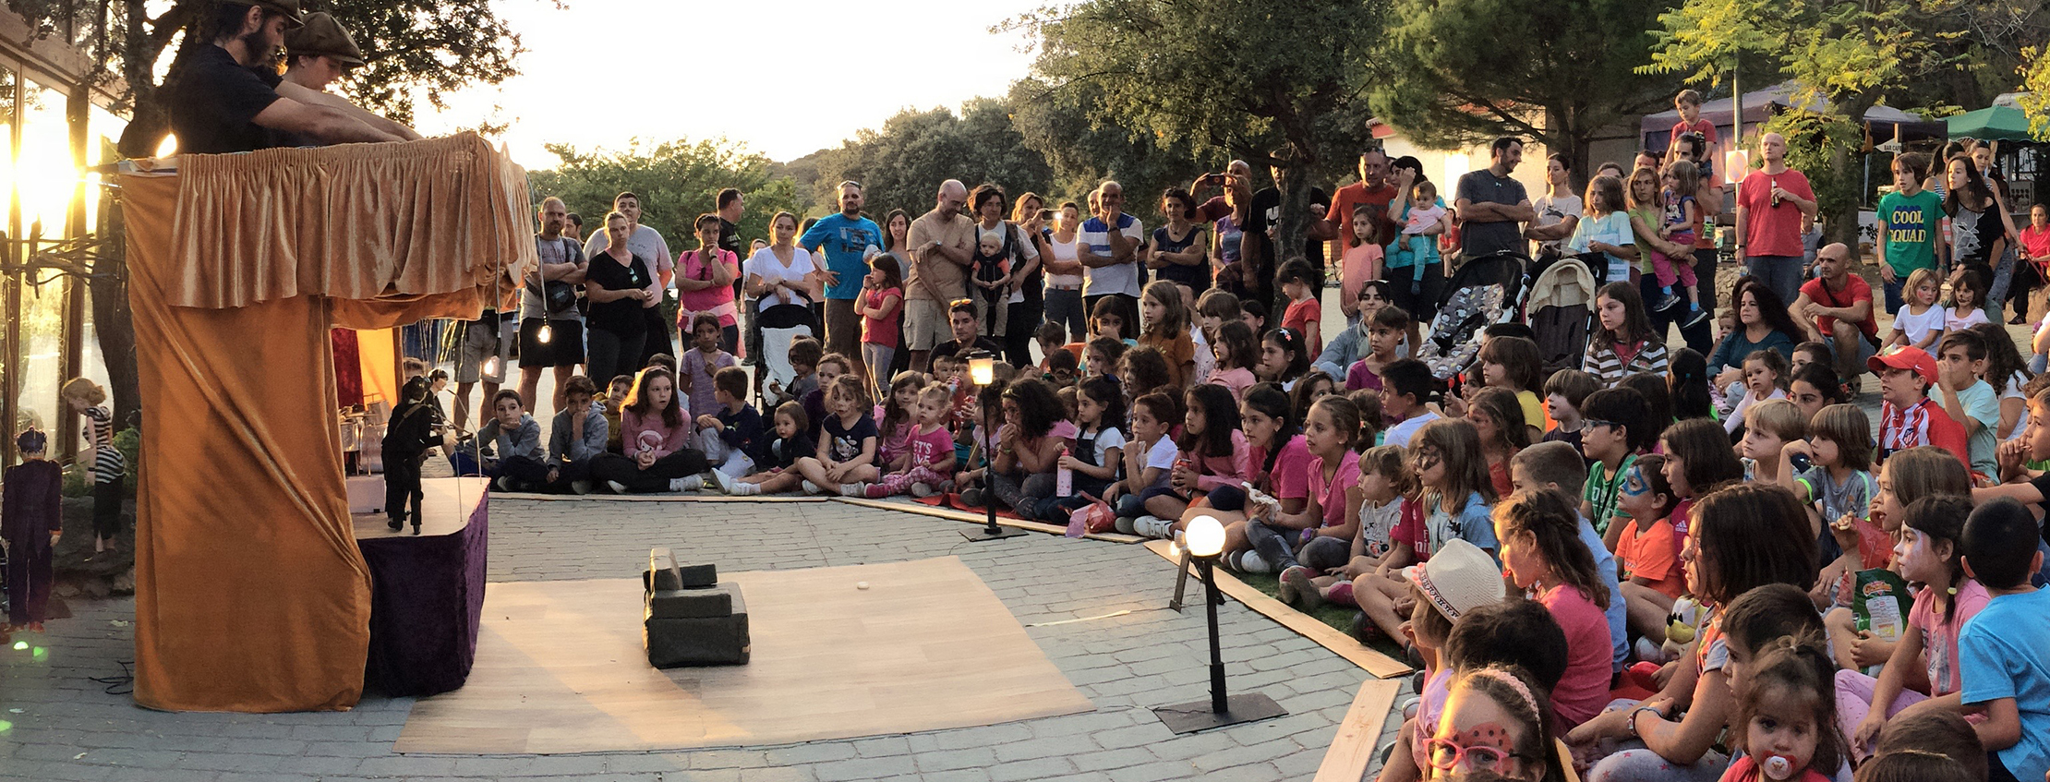

Compañía Periplo Marionetas

Periplo Marionetas are Diana Romero and Andrés Maturana: designers and makers of puppets and stories.
We began in 2003 in Barcelona studying self-taught at Institut del Teatre Library and test our puppets at the streets. We traveled around Europe and America gathering information and experience, until in 2009 we decided live in Madrid and be a Theatre company.
We start our Periplo! Design realistic puppets to tell non-real stories, with our passions: design, puppets, film and music. Since then our shows and puppets have been:

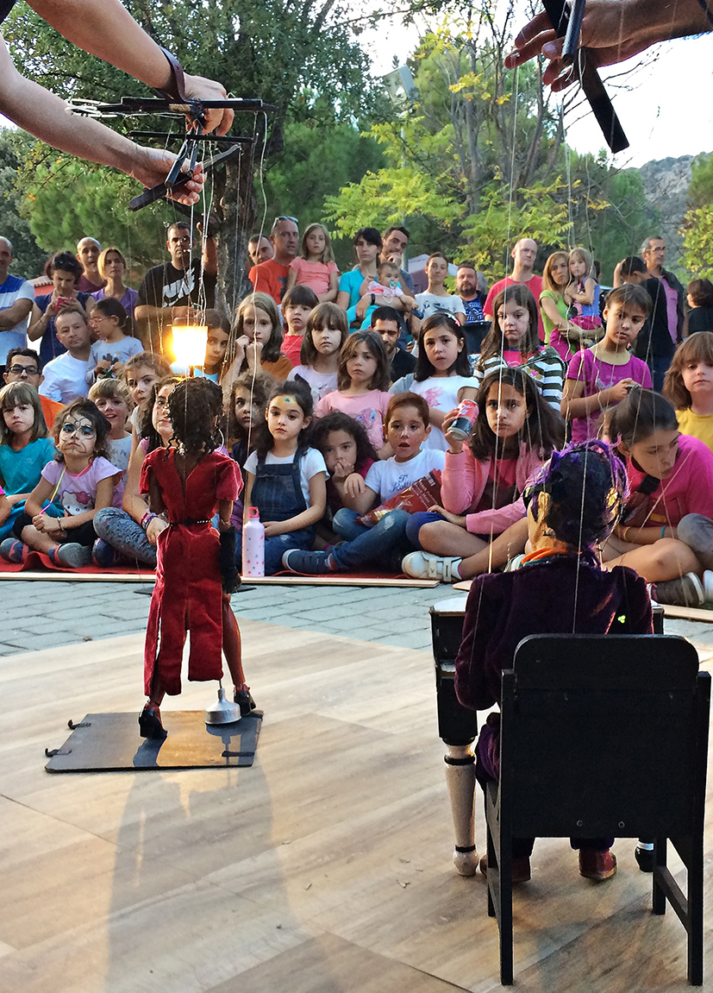

• International Festivals:
Titirimundi Segovia (Spain), FIMFA Lisboa (Portugal), FIB Brasilia (Brazil), Umore Azoka Leioa (Spain), AR.CA Palencia (Spain), FIROBI Barcelona (Spain), Tampere B. Happening Finland, Bristol Festival of Puppetry (UK), International Beatleweek Liverpool (UK), FIMO Oporto (Portugal), Festival Mondial de Théâtre des Marionnettes Charleville-Mézière (France), Bienal Theatre of Ceará (Brazil), Internacional Puppets Festival from El Retiro Madrid (Spain), MIMMOS Sintra (Portugal), Aurillac Festival (France).
. Awards and special mentions:
Audience award: Best show at the International Exhibition of Artists Aranda de Duero 2010.
Finalist with special mention at the TEA Contemporary Theater Festival (Toledo Open Scene) 2018.
. Campañas escolares:
Campaña escolar en Finlandia e IES Comunidad de Madrid.
. Events:
Marionette Museum of Lisbon Inauguration, San Isidro Madrid Festivities, Madrid Book Fair.
• Music VIdeos:
Selig (Universal, Germany), 4 Gatos (Avispa, Spain), Enrique Iglesias y Pitbull (Universal, Miami).
• TV Commercials:
Hema, Holanda y Optimus, Portugal.

www.titeresymarionetas.com

info@titeresymarionetas.com

+34 649584481

Instagram: @periplomarionetas
Facebook: @periplomarionetas
Twitter: @periplomarionet

